MRI Brain Scan Tumor Detection with Segmentation
July 28, 2011
EECE 466
Bill Liu - 63461081
Patrick Yao - 61348082

Abstract
With increasing awareness of human health and life, detection of diseases and illnesses are important in successful treatment. In this project, we attempt to implement automated regions of interest tumor detection. A series of distinct modules with work together in the system: threshold, blur, asymmetric, and perimeter filters. Symmetry property of the human anatomy is exploited and each input image is preprocessed with cross correlation in order to simplify asymmetric detection. The result is segmented and outlined in a graphical user interface which allows ease of visual feedback and input.

Table of Contents
Abstract 2
List of Figures and Tables 3
Abbreviation 3
1 Introduction 3
2 Requirement, Constraint, Goal 4
2.1 Goal 4
2.2 Requirement 4
2.3 Constraint 4
3 Overall Tumor Detection Method 4
4 Image Pre-processing 4
4.1 Center the Object in the Image 4
4.2 Rotate the Object in the Image 5
5 Segmentation 6
5.1 Threshold filter 6
5.2 Blur Filter 6
5.3 Asymmetric Mask 6
5.4 Perimeter Mask 7
5.5 Integration 7
6 Evaluation of Tumor Detection 8
7 Conclusion 8
Borrowed Sources 9
Appendix (code) 10

List of Figures and Tables
Figure 1. System Flow Chart .................... 4
Figure 2. Centering the Image .................. 5
Figure 3. Correlation by Rotation ............. 5
Figure 4. Correlation Result ..................... 5
Figure 5. Threshold Intensity ................... 6
Figure 6. Blur Filtered .............................. 6
Figure 7. Asymmetric Mask ..................... 6
Figure 8. Perimeter Mask ......................... 7
Figure 9. Post-Asymmetric Masking ....... 7
Figure 10. Post-Perimeter Masking ......... 7
Figure 11. GUI ......................................... 7

Table 1. Tumor Image Accuracy ............. 8
Table 1. Non-Tumor Image Accuracy ..... 8

Abbreviation
MRI - Magnetic Resonance Imaging. Imaging technology that use magnetization property of atom to detect different types of tissues in the body
T1 MRI – Type 1 MRI scan that highlight cells with high water concentration as white intensity while fat containing cells are shown as darker regions.
T2 MRI – Type 2 MRI scan that highlight fatty cells as white intensity while water saturated cells are shown as darker regions.

1 Introduction
Magnetic resonance imaging (MRI) is a medical imaging technique that is typically used to differentiate different types of cells in the body, particularly fatty tissues. A MRI scans uses a non-invasive procedure that strongly magnetize atoms in the cell and detects the response time for them to align to the externally applied magnetic field. Tissues such as tumors in the body are shown with good contrast against surround fatty tissues.
The automated system we devised for this project takes in MRI scans of the human brain and outlines potentially tumorous regions in the image. To make this project possible, image processing techniques such as value threshold, spatial frequency filtering, finding image centroid, and cross correlation are used.
In addition to implementing a system algorithm, a graphical user interface is created to enable ease of switching between selectable input image and rich visual feedback.

2 Requirement, Constraint, Goal

2.1 Goal
The goal of this project is to create a visual feedback image processing system that automates tumor detection in MRI brain scans with as few user inputs as possible.

2.2 Requirement
The system has to detect potentially tumorous regions from MRI brain scans and display regions of interest on top of the original image. System has to work with input images that have different orientation.

2.3 Constraint
The system is limited to a single slice image for analysis.

3 Overall Tumor Detection Method
Using T2 MRI technology, areas of the brain with greater water concentration are represented with greater intensity on an MRI scan, while fatty tissues are represented by darker regions with less intensity. T1 MRI requires more processing power since black background conflicts with dark areas that represent water concentrated regions, therefore T1 MRI scans are exclusively used as input images for the system.
One major obstacle is that MRI scan is able to reveal water concentrated tumor regions as well as other parts of the nervous system that are high in water concentration. Without full 3D slice scans and limited to single slice images, tumors shape may be irregular in nature therefore feature detection is not a viable choice.
MRI scanning orientation plays a major role in increasing chance of tumor detection in single slice image input. Since most cells in the human body is symmetrical when cut by the median plane, we can utilize it to our advantage when eliminating normal cells that are show up in the MRI scan. Therefore axial plane T2 MRI scans are used for tumor diagnosis.
The main modules include threshold and noise filter to extract white intensity (water rich) regions, asymmetric mask to eliminate water rich normal tissue that are largely symmetric. Input images are pre-processed through centring and rotating modules to allow ease of creating a asymmetric mask.

Figure 1. System Flow Chart
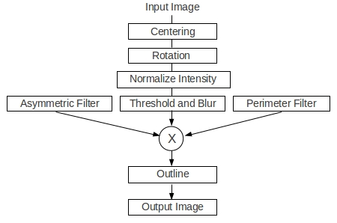

4 Image Pre-processing

4.1 Center the Object in the Image
As part of the constraint, the system allows a variation of input image orientation. Centering a scan allows ease of asymmetrical filtering. The coordinate of the image center is calculated from the input image dimensions as half of width and half of height.
The center of mass in the image is found using the formula below for each dimension, where x is the location and g(x) the intensity sum of column or row at x. Then, the whole brain mass is then translated to the image center.
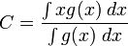

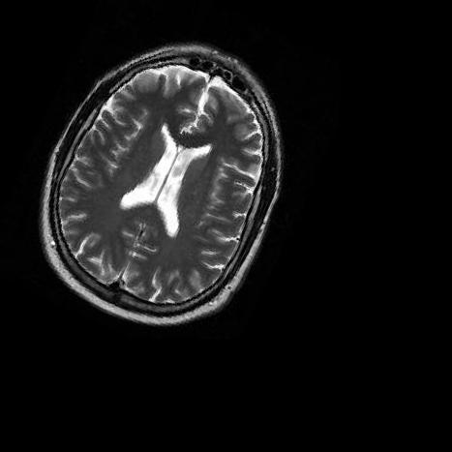
Figure 2. Before and After Centering the Image
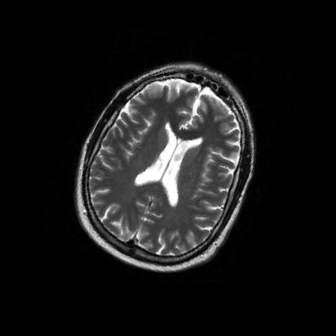

4.2 Rotate the Object in the Image
The brain mass in image is rotated so that the brain is vertically divided into two equal parts and each side mirrors the other. This allows ease of asymmetric filtering.
Threshold filtering is used to fill the entire inside of the skull cavity to a binary intensity of 1 and everything else 0.
Cross correlation is used as the system rotates the image 180 degrees in small increments. It is possible to calculate the correlation between left and right side of the brain because the brain is not a perfect sphere as seen in the axial plane, in fact is it oval. Implementing 360 degree rotation is twice as redundant, slower and produces the same effect as 180 degree rotation since upright and upside down images are both symmetrical in left and right.
During each step of increment, the left half of the image is flipped horizontally and correlated with the right half of the image. This multiplication, pixel by pixel allows calculation of the total size of the overlapped region.
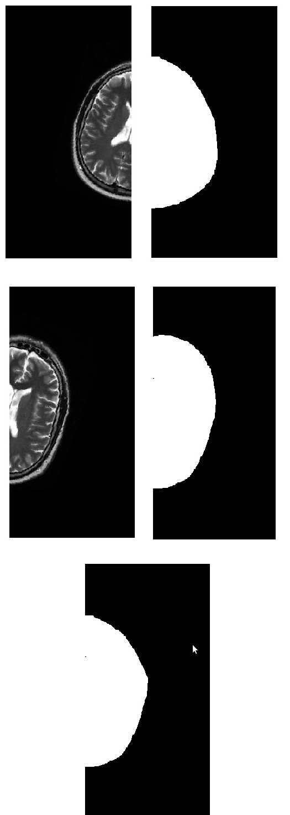
Figure 3. Correlation by Rotation

Mirroring left side and fill cavity

Fill right cavity

Multiplication

After 180 degree rotation, the highest overlapped value corresponds to an angle of rotation that yields most symmetry. Then entire image is rotated by this angle.

Figure 4. Correlation Result
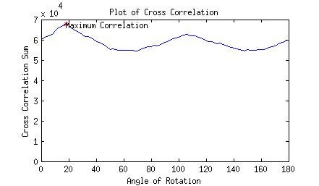

5 Segmentation

5.1 Threshold filter
Threshold filtering is used to easily obtain regions of interest since tumorous cells shows up as relatively high intensity regions. The image intensity is normalized so that darkest intensity is 0 and the highest intensity is 1.
The image is smoothed out with a low pass spatial frequency filter to remove jitters. We chose a filter that turn very rough edges to smoother curves in the picture while retaining most of the detail.
Figure 5. Threshold Intensity
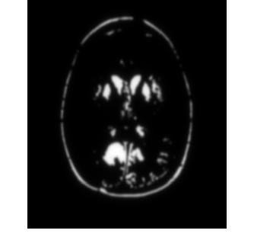

5.2 Blur Filter
To improve the performance of the asymmetric mask, the original image undergoes low pass or blurring. This expands the shape of the high intensity areas. This is done because the left and the right sides of the brain scan are not completely symmetrical, and expanding these largely symmetrical shape decrease the amount of unwanted residues in the creation of asymmetric mask.

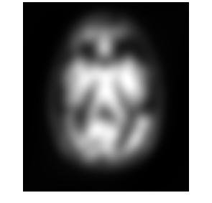
Figure 6. Blur Filtered

5.3 Asymmetric Mask
Regions of high intensity in a T2 MRI scan also reveal parts of the brain such as the cortex, lateral ventricle, and falx cerebri because the brain floats in a cerebrospinal fluid. Dividing the human body with the median plane results in largely left and right symmetry of the brain. Meanwhile, tumor cells are irregular and highly asymmetric with respect to the median plane.
Using this observance, a mask is created by subtracting overlapping regions. The right side is subtracted by the mirrored left side. The left side is subtracted by the mirrored right side. The high intensity regions in the asymmetric mask shows asymmetric regions.
Figure 7. Asymmetric Mask
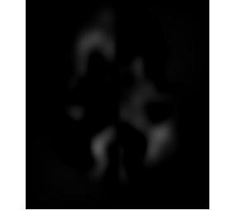

5.4 Perimeter Mask
Due to imperfection of the asymmetric mask as well as typically thin and high intensity cortex region at the perimeter of the brain, white traces are left behind after asymmetric mask.
A perimeter mask is used to filter out exterior regions just including the cortex. This is done by filling the inside of the skull to solid white intensity and using a low pass filter to blur the boundary. Image is threshold filtered to obtain a smaller brain cavity which excludes the the cortex.

Figure 8. Perimeter Mask
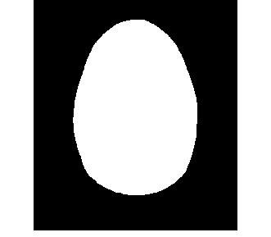

5.5 Integration
Output from the threshold and noise filter is multiplied pixel by pixel with the asymmetric mask to produce regions that are asymmetric and high in intensity. This is further multiplied pixel by pixel with the perimeter mask to exclude the cortex. The final regions of interest are again threshold filtered to Boolean logic. The regions are outlined in colour and finally combined with the original grayscale image for visual feedback.
Figure 9. Post-Asymmetric Masking
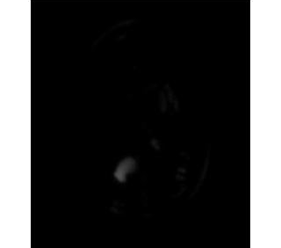
Figure 10. Post-Perimeter Masking
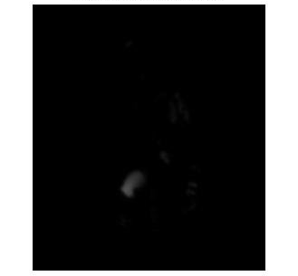
The system is integrated with graphical user interface for loading image, adjusting threshold intensity, intermediate filtering stages, and final visual feedback of the diagnosis.
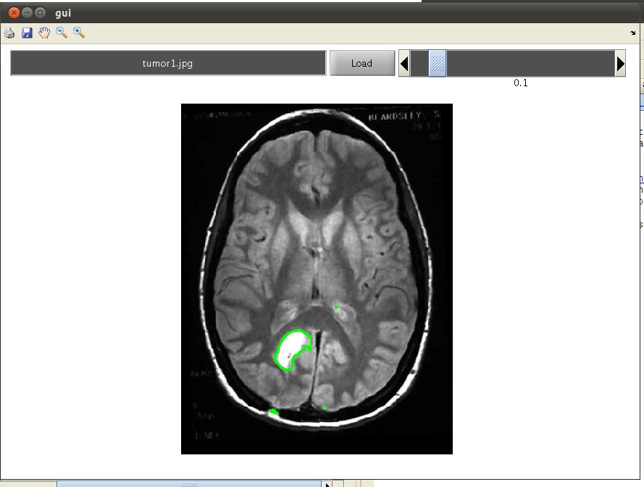
Figure 11. GUI

6 Evaluation of Tumor Detection
The accuracy of orientation correction of the MRI brain scan is based on the observable symmetric property and the oval skull shape from the axial plane MRI. 100% of test images, after undergoing orientation correction, show acceptable orientation for both normal and tumor infected brain scans.
Although subjective, results of applying asymmetric mask show that the system is effective in detecting large symmetric regions but not all small shape variations in symmetry.
The high irregularity of shape, size, and sometimes intensity of the tumor regions does not allow distinct feature extraction method from a single slice MRI scan. Detectable regions of interest expands and shrinks as the intensity threshold value changes, and so this is a major weakness of the system.
By fixing different threshold values of the out liner at the last stage of this system, we are able to evaluate the accuracy of the system based on subjective evaluation of accuracy on size of error regions.
Table 1. Tumor Image Accuracy
Threshold Value | 0 | 0.03 | 0.06 | 0.09 | 0.12
Perfect |  | 1 | 1
Very Accurate |  | 1 | 2 | 3 | 3
Moderate Accurate | 1 |  | 2 | 1 | 1
Less Accurate |  | 3 |  | 1 | 1
Very inaccurate | 5 | 1 | 1 | 1 | 1
Threshold Value | 0.15 | 0.18 | 0.21 | 0.24 | 0.27
Perfect |  | 3 | 1
Very Accurate | 3 |  | 2 | 2 | 2
Moderate Accurate |  |  |  | 2 | 1
Less Accurate | 1 |  | 1 |  | 1
Very inaccurate | 2 | 3 | 2 | 2 | 2

Table 2. Non-Tumor Image Accuracy

Threshold Value | 0 | 0.03 | 0.06 | 0.09 | 0.12
Perfect | 1 | 1 | 1 | 1 | 1
Very Accurate |  |  |  | 1 | 1
Moderate Accurate |  |  | 1 | 3 | 3
Less Accurate |  | 3 | 3 | 2 | 1
Very inaccurate | 5 | 2 | 1
Threshold Value | 0.15 | 0.18 | 0.21 | 0.24 | 0.27
Perfect | 2 | 2 | 2 | 4 | 5
Very Accurate | 3 | 3 | 4 | 2 | 1
Moderate Accurate |  | 1
Less Accurate | 1
Very inaccurate

From test results, diagnosis accuracy on non-tumor images increases as threshold increases. However, optimum threshold is between 0.09 and 0.12 for diagnosis on tumor containing images.
A user selectable threshold variable is implemented in the GUI of the system for flexible evaluation just before regions of interest are outlined and superimposed on the original image.

7 Conclusion
The project implements automated tumor detection of an input MRI brain scan and segmentation of regions of interest. Main use of threshold filter, blur filter and asymmetry property proved to be not always perfect, but show moderate to accurate results on single slice axial T2 MRI brain scans.

Borrowed Sources

Matlab Image Processing Toolbox. Functions:
Imadjust
Immultiply
Imrotate
Imshow

Fahd Ahmad Abbasi. Code: ait_centroid
http://www.mathworks.com/matlabcentral/fileexchange/5457-centroid-calculation-function

Valeriy Korostyshevskiy. Code: gray2rgb
http://www.mathworks.com/matlabcentral/fileexchange/13312-grayscale-to-rgb-converter

Appendix (code)

